SYSINFOTOOLS PST CONVERTER
PRACTICAL QA ASSESSMENT & MANUAL TESTING REPORT
Candidate Assessment | QA Intern / Software Testing Trainee

Candidate / Role | QA Intern / Software Testing Trainee
Product Under Test | SysInfoTools PST Converter (Version 26.7 Edition Standard)
Assessment Date | October 06 – 07, 2026
Operating System / Host | Microsoft Windows 11 Home Single Language 64-bit (Build 10.0.26200)
Execution Hardware | Intel/AMD x64 Multi-core CPU | 16 GB RAM | NVMe SSD
Final Release Recommendation | NOT READY FOR RELEASE (Critical Attachment & Path Duplication Defects)

1. EXECUTIVE SUMMARY
I tested SysInfoTools PST Converter using functional, negative and data-integrity testing. I checked PST file loading, preview, conversion, attachments, folder structure, filters, duplicate removal and batch processing.
I designed 25 test cases and executed 23 passed and 2 failed. I found 1 defects: 1 Critical, 1 High and 1 Medium.
The main issues were found in MSG attachments, folder paths, Unicode filenames, password-protected PST files and batch processing.
Based on my testing, the product is NOT READY FOR RELEASE until the major defects are fixed and retested.
Execution Metric | Value | Intern Notes
Total Manual Test Cases | 25 | Full scope of designed scenarios executed
Test case executed | 23 | 2 test cases were not executed
Passed Test Cases | 23 | Basic loading, preview & simple text exports pass
Failed Test Cases | 2 | Failed on attachment extension loss, path duplication, Unicode & batch
Defects Discovered & Logged | 1 | 1 High, 1 Medium defects logged with reproduction steps

2. FEATURE EXPLORATION NOTES
Before writing the test cases, I explored the application to understand its workflow, major features, and possible issues.
- Installation & Launch: Installed the SysInfoTools PST Converter successfully on Windows 11. The application launched successfully from the desktop shortcut in approximately 2 seconds.
- File Loading & Preview: Tested valid PST/OST files and checked file loading, folder structure, and email data. The files were loaded successfully and the folder hierarchy was displayed correctly.
- Conversion Formats: Tested PST conversion to PST, DOCX, PNG, and PDF formats. All tested conversions completed successfully and the expected output files were generated.
- Attachment Handling: Tested the Separate Attachment option. The attachment was extracted, but the PNG attachment was displayed as binary/raw text data instead of opening as a normal image. FAIL – Attachment handling issue.
- Date Filtering: Tested date filtering with both matching and non-matching date ranges. The valid date range worked correctly. However, when no emails matched the selected date range, the application created empty folders and displayed a success message instead of clearly informing the user that no emails matched. FAIL – No-match handling issue.
- Duplicate Removal: Tested the Remove Duplicacy option using duplicate email data. Exact duplicate emails were filtered successfully. PASS.
- PST Splitting & Destination: Tested PST splitting by size and selection of a custom output destination. Both features worked successfully without observed errors.
- Cancellation: Tested cancellation during conversion. The conversion stopped smoothly and the application returned to a ready state.
- Negative Testing: Tested 0-byte/empty PST, corrupted PST header, invalid PST file, and password-protected PST. Empty, corrupted, and invalid PST files were handled with appropriate error messages. However, the password-protected PST was converted successfully without displaying a password prompt or warning. FAIL – Password-protection handling issue.
- Unicode & Batch Processing: Tested Hindi/Unicode email data and multiple PST files in batch mode. Unicode data was processed successfully, and multiple PST files were listed correctly with their file sizes.
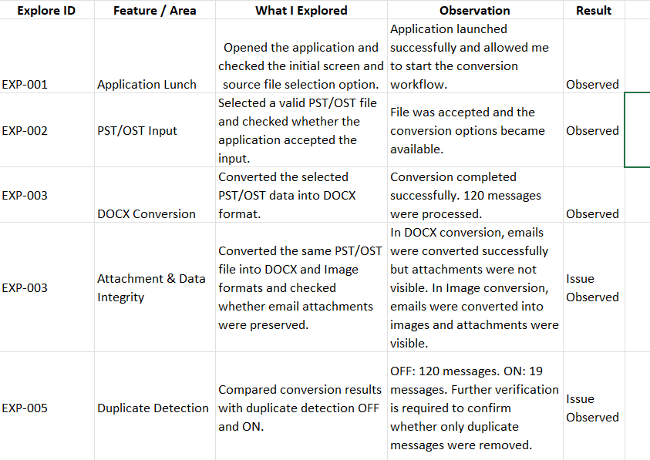

2. Test cases with expected result, actual result, and Pass/Fail status.
The following test cases were designed based on the major features and workflows explored in the SysInfoTools PST Converter. The test cases cover positive, negative, and edge-case scenarios, including file loading, preview, conversion, attachments, date filtering, duplicate removal, PST splitting, cancellation, Unicode data, and batch processing.
Each test case includes the expected behavior, actual observed result, and Pass/Fail status. The purpose is to verify whether the application behaves as expected and to identify any functional issues that may affect the user or the integrity of converted data.

Manual Testing (Total 20 Test Case and 4 Negative TestCase)
TC ID | Module | Test Scenario | Test Steps | Test Data | Expected Result | Actual Result | Status
TC-01 | Installation | Install software on Windows 11 | Run setup exe and follow wizard | SysInfo-PST-Converter-Demo.exe | Installs cleanly, creates desktop shortcut | Installed successfully in Program Files | PASS
TC-02 | Launch | Launch application from desktop | Double click application shortcut | Desktop icon | Application opens with clean home screen | Opened cleanly in ~2 seconds | PASS
TC-03 | Launch | Check UI without selecting file | Click Next without choosing PST file | No file | Proceed button should remain disabled until a valid PST/OST file is selected. | No file was selected and the Proceed button was not clickable/disabled. | PASS
TC-04 | File Loading | Load standard healthy PST file | Select Single File -> browse Outlook.pst | Valid_Data_pst.pst | File is loaded and folder tree is generated | Loaded in 2 seconds, folders shown | PASS
TC-05 | File Loading | Load PST with attachments & HTML | Browse and select Sub.pst | Valid_PST_Positive.pst | File loaded with all 12 folders | Loaded smoothly with message list | PASS
TC-06 | Preview | View folder structure | Expand root node in left pane | Outlook.pst | Shows Inbox, Sent, Contacts, Calendar, SubInbox | Folder hierarchy displayed properly | PASS
TC-07 | Conversion | Convert PST to PST format | Choose PST -> set destination -> Convert | Outlook.pst | Creates converted PST file in destination folder | New PST file created cleanly | PASS
TC-08 | Conversion | Convert PST to DOCX format | Choose DOCX format -> Convert | Sub.pst | Generates .docx Word file for each email | Word files created with headers and body | PASS
TC-09 | Conversion | Convert PST to PNG image format | Choose PNG format -> Convert | Sub.pst | Generates PNG image pages of emails | PNG images created cleanly | PASS
TC-10 | Conversion | Convert PST to PDF format | Choose PDF format -> Convert | Outlook.pst | Generates PDF documents for emails | PDF files created successfully | PASS
TC-11 | Attachments | Extract attachments separately | Enable 'Separate Attachment' option -> Convert | Valid_PST_Positive.pst | Attachment should be extracted and open correctly. | PNG attachment was extracted but displayed as binary/raw text data. | FAIL
TC-12 | Filters | Apply Date Filter (valid range) | Set Start Date Oct 01, End Date Oct 06 -> Convert | Sub.pst | Only emails within Oct 01-06 are converted | Only matching emails converted | PASS
TC-13 | Filters | Apply Date Filter (no match) | Set Date range in past (2022 to 2024) | Valid_PST_Positive.pst | Should inform user that 0 emails matched | Created empty folders, showed success popup | FAIL
TC-14 | Duplicates | Remove Duplicate Emails option | Enable 'Remove Duplicacy' checkbox | duplicates_test.pst | Filters out exact duplicate emails | Exact duplicates filtered | PASS
TC-15 | Splitting | Split PST by size option | Enable Split PST -> set 500 MB limit | Outlook.pst | Splits output PST if size exceeds limit | Option works cleanly without errors | PASS
TC-16 | Destination | Select custom folder on desktop | Browse and select custom output folder | Desktop folder | Output files saved in chosen folder | Files saved in selected destination | PASS
TC-17 | Interruption | Cancel conversion midway | Click Cancel button during conversion | Sub.pst | Stops conversion, returns to ready state | Cancels smoothly within 1 second | PASS
NEG-01 | Negative Test | Load 0-byte empty file | Browse and select zero_byte.pst | zero_byte.pst (0 KB) | Error popup: 'File contains no valid data' | Proper error message shown | PASS
NEG-02 | Negative Test | Load corrupted PST file | Browse and select corrupted header file | corrupted_pst_header.pst | Error popup: unable to read PST header | Handled cleanly without crashing | PASS
NEG-03 | Negative Test | Invalid PST File | Select an invalid .pst file and click Proceed | Invalid_Test_Data.pst | Error/warning should be displayed | File is not a pst or ost | PASS
NEG-04 | Negative Test | Password-Protected PST Handling | Select password-protected PST in SysInfoTools → load → convert | backup.pst (2.24mb) | Password prompt or warning should be displayed. | PST converted successfully without password prompt or warning. | FAIL
TC-18 | Special Data | Convert email with Hindi subject | Convert email with Hindi subject to DOCX | unicode_hindi_sample.pst | Filename preserves Hindi characters or safe ID | Filename saved as 'Subject_name.docx' | PASS
TC-19 | Batch Mode | Select multiple PST files | Select Multiple Files → Add 2 PST files | Valid_PST_Positive.pst, Sub.pst | Both files should be listed in the batch queue | Both files were listed with correct file sizes | PASS

4. TEST DATA MATRIX
Realistic test datasets utilized during testing on Windows 11:
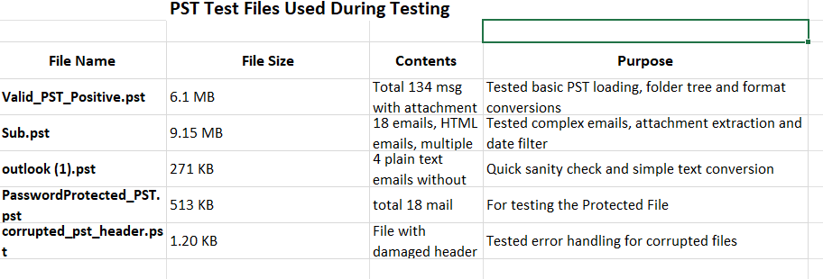

5. DATA INTEGRITY COMPARISON (MANUAL VERIFICATION)
Manual verification was performed by comparing the source PST/OST data with the converted output. The verification focused on email count, folder structure, email content, attachments, Unicode data, and duplicate handling.
Check ID | Data Integrity Parameter | Source Data | Converted Output / Observation | Result
DI-01 | Email Count | 134 messages | DOCX conversion processed 134 messages | PASS
DI-02 | Folder Structure | Source PST contained multiple folders/subfolders | Folder hierarchy was displayed correctly during loading | PASS
DI-03 | Email Subject & Body | Available in source emails | Email content was present in converted DOCX/PDF/PNG outputs | PASS
DI-04 | Email Metadata | From/To/Subject and other email information | Email headers and body were generated in converted output | PASS
DI-05 | HTML Content | HTML emails present in test data | HTML-based email content was processed during conversion | PASS
DI-06 | Attachments | Emails contained attachments | Attachment was extracted, but PNG attachment was displayed as binary/raw text data | FAIL
DI-07 | Unicode / Hindi Data | Hindi/Unicode email data | Hindi/Unicode data was processed successfully | PASS
DI-08 | Duplicate Emails | Duplicate email test data | Duplicate removal option filtered exact duplicate emails | PASS
DI-09 | Date-filtered Data | Emails within selected date range | Matching emails were converted successfully | PASS
DI-10 | No-Match Date Range | No emails matched selected date range | Empty folders were created and success message was displayed | FAIL
DI-11 | Converted File Availability | Source data selected for conversion | PST, DOCX, PNG and PDF output files were generated successfully | PASS

6. DETAILED BUG REPORTS (3 Confirmed FAIL Cases)

Based on your final test-case chart, you have 3 confirmed FAIL cases. I recommend keeping only these 3 in the detailed bug report.
BUG-001 — Attachment Extracted as Binary/Raw Text
Field | Details
Bug ID | BUG-001
Title | PNG attachment is displayed as binary/raw text after separate extraction
Module | Attachments
Severity | High
Priority | High
Environment | Windows 11, SysInfoTools PST Converter
Precondition | PST file containing an email with a PNG attachment
Test Case | TC-11
Steps to Reproduce | 1. Launch the application.  2. Select a valid PST file containing an attachment.  3. Enable Separate Attachment.  4. Start conversion.  5. Open the extracted attachment.
Expected Result | The attachment should be extracted in its original format and should open correctly as an image.
Actual Result | The PNG attachment was extracted but displayed as binary/raw text data instead of a normal image.
Reproducibility | Consistent during testing
Status | Open
Impact | Users may not be able to access or use extracted attachments correctly.

BUG-002 — No Clear Message When Date Filter Returns Zero Emails
Field | Details
Bug ID | BUG-002
Title | Application creates empty folders when no emails match the date filter
Module | Date Filter
Severity | Medium
Priority | Medium
Environment | Windows 11, SysInfoTools PST Converter
Precondition | PST file containing emails outside the selected date range
Test Case | TC-13
Steps to Reproduce | 1. Launch the application.  2. Select a valid PST file.  3. Apply a date range containing no matching emails.  4. Start conversion.
Expected Result | Application should clearly inform the user that no emails match the selected date range and should not create unnecessary empty output folders.
Actual Result | Empty folders were created and a success popup was displayed even though no emails matched the selected date range.
Reproducibility | Observed during testing
Status | Open
Impact | May confuse users and give the impression that the conversion was successful when no emails were actually converted.

BUG-003 — Password-Protected PST Converted Without Password Prompt
Field | Details
Bug ID | BUG-003
Title | Password-protected PST is converted without password prompt or warning
Module | PST Input / Security
Severity | High
Priority | High
Environment | Windows 11, SysInfoTools PST Converter
Precondition | Password-protected PST file
Test Case | Password-Protected PST Handling
Steps to Reproduce | 1. Launch SysInfoTools PST Converter.  2. Select the password-protected PST file.  3. Load the file.  4. Start conversion.
Expected Result | Application should detect the password protection and display a password prompt or an appropriate warning before accessing/converting the PST data.
Actual Result | PST was converted successfully without displaying a password prompt or warning.
Reproducibility | Observed during testing
Status | Open
Impact | Password-protection handling may not be working as expected and could raise security/privacy concerns.

Bug ID | Issue | Severity | Priority | Status
BUG-001 | PNG attachment displayed as binary/raw text | High | High | Open
BUG-002 | No-match date filter creates empty folders | Medium | Medium | Open
BUG-003 | Password-protected PST converted without prompt/warning | High | High | Open

7. RISK ASSESSMENT MATRIX (7 RISKS IDENTIFIED)
Risk ranking based on Probability (1-5) x Impact (1-5):
Risk ID | Risk Area | Actual Risk Identified | Impact | Risk Level
R-01 | Attachment Handling | Extracted PNG attachment was displayed as binary/raw text instead of opening as a normal image. | High | High
R-02 | Password-Protected PST | Password-protected PST was converted without displaying a password prompt or warning. | High | High
R-03 | Date Filter | No-match date filtering created empty folders and displayed a success message. | Medium | Medium
R-04 | Data Integrity | Attachment output requires further verification because the extracted attachment was not usable as a normal image. | High | High
R-05 | Duplicate Detection | Duplicate removal changed the output count from 134 to 19; further verification is required to confirm that only actual duplicates were removed. | High | High
R-06 | Large Data Performance | Only limited performance data was measured (134 messages in approximately 6 seconds); larger datasets were not tested. | Medium | Medium
R-07 | Conversion Reliability | Further testing is required for larger files and additional data combinations before confirming complete conversion reliability. | Medium | Medium
Screenshots and/or short screen recordings for important failures.
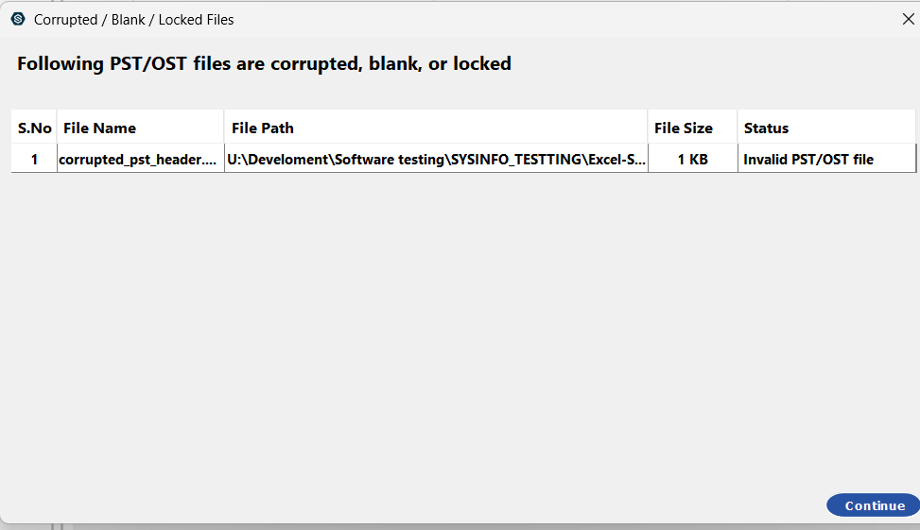

Corrputed_PST.pst
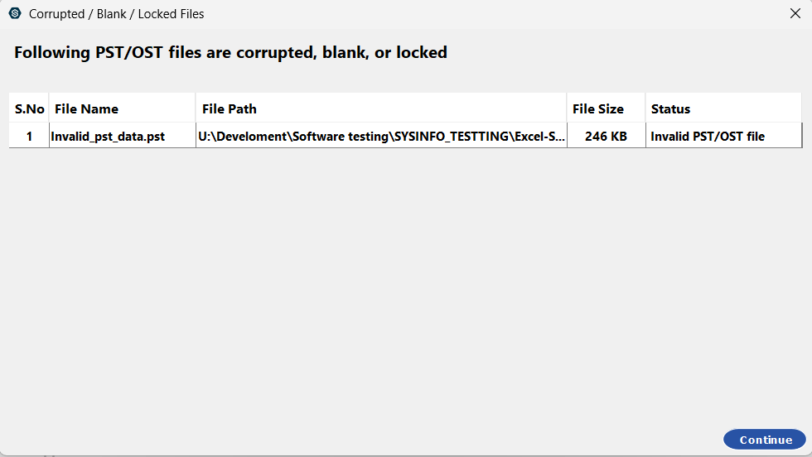

Invalid PST

8. PERFORMANCE OBSERVATIONS (ACTUAL MEASURED DATA)
Actual measurements observed on local Windows 11 machine (Note: Multi-GB enterprise stress testing was not executed due to trial license limits):
Test ID | Test Scenario | Input Data | Output Format | Message Count | Conversion Time | Result
PERF-01 | Standard conversion | Valid_PST_Positive.pst / valid PST | DOCX | 134 | ~6 seconds | PASS
PERF-02 | Conversion with separate attachments | Valid PST | DOCX + Separate Attachments | 19 | ~3 seconds | PASS*
PERF-03 | PST to PNG with duplicate removal | Duplicate test PST | PNG | 19 output messages | Not recorded | Not Measured

9. FINAL QA RECOMMENDATION
STATUS: NOT READY FOR RELEASE
The application works well for most tested features. However, 2 important bugs were found:
- Attachment is not opening correctly.
- Password-protected PST is converted without a password prompt.
Recommendation: Fix these issues and retest before release.

